- Install nginx and run nginx on port number 81.
Yum install nginx -y to install nginx
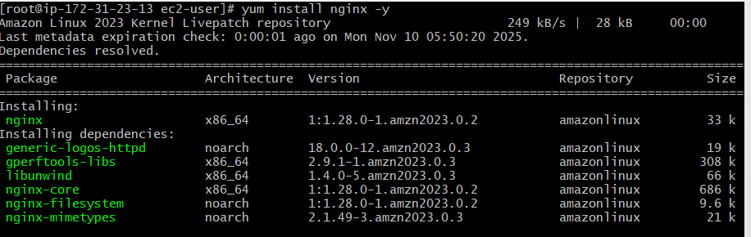
/etc/nginx/nginx.conf

- 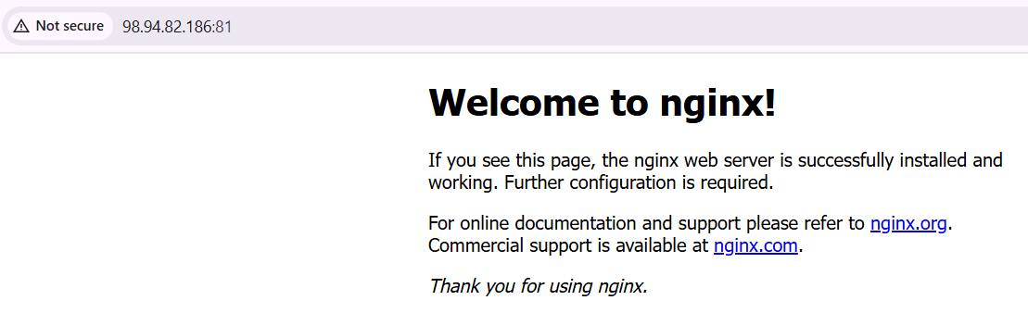Deploy a sample index.html file on nginx.
The default deployment location : /usr/share/nginx/html/

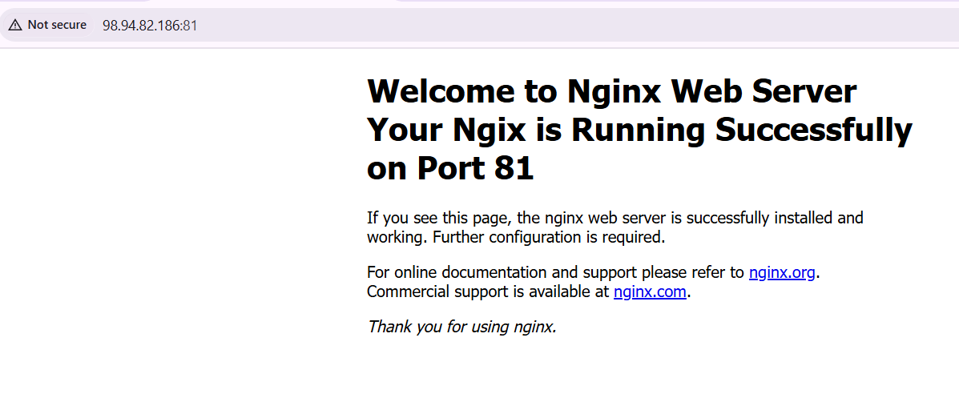

- Install Apache and run Apache on port number 82
Yum install httpd
/etc/httpd/conf/httpd.conf
4.Deploy a sample index.html file on Apache.
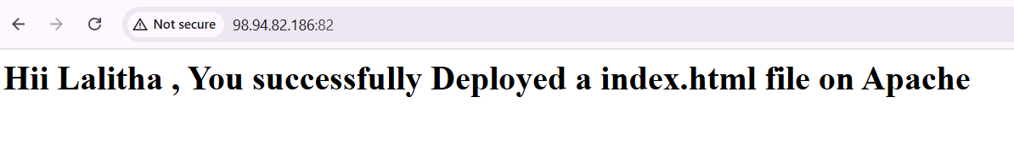

5.Install Apache tomcat on port number 8082
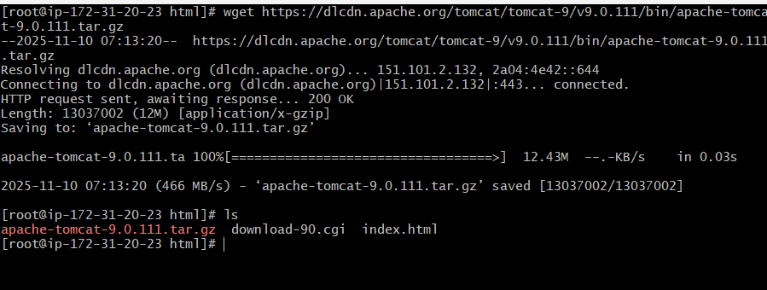
tar xvf apache-tomcat-9.0.111.tar.gz to extract the file
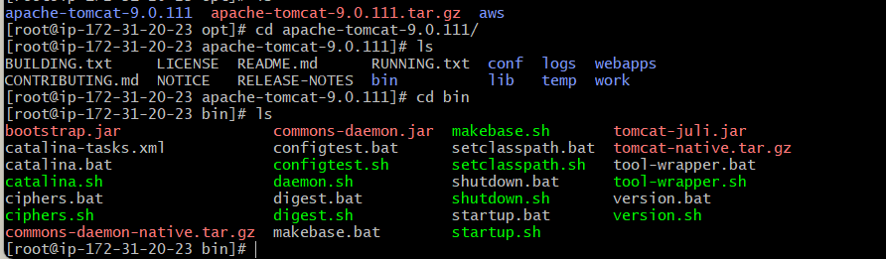
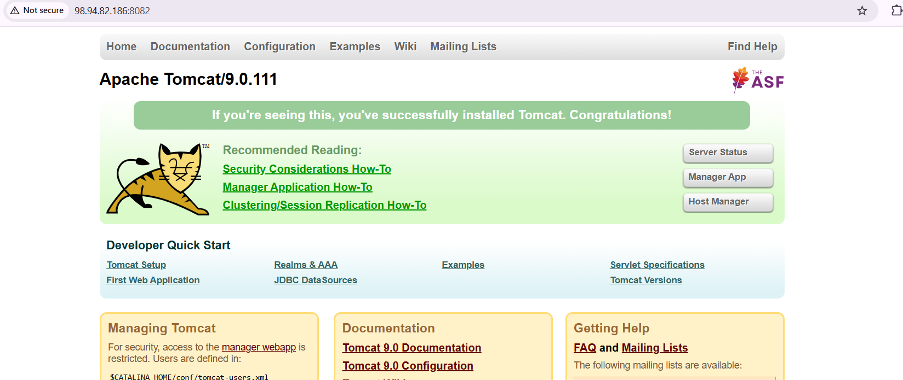
6.Deploy a sample app on webapps
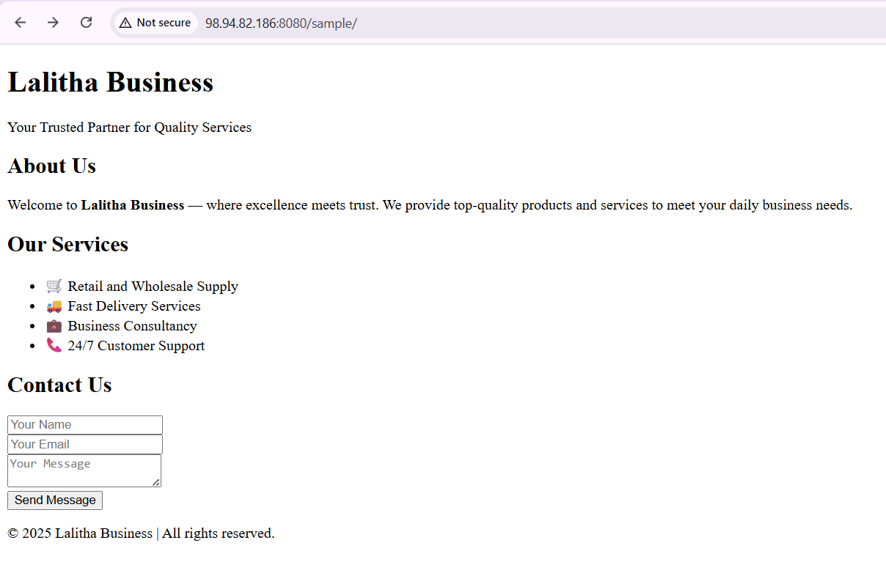
7.Create a tomcat.service file for tomcat.
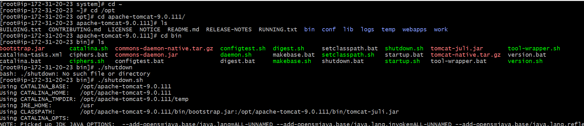
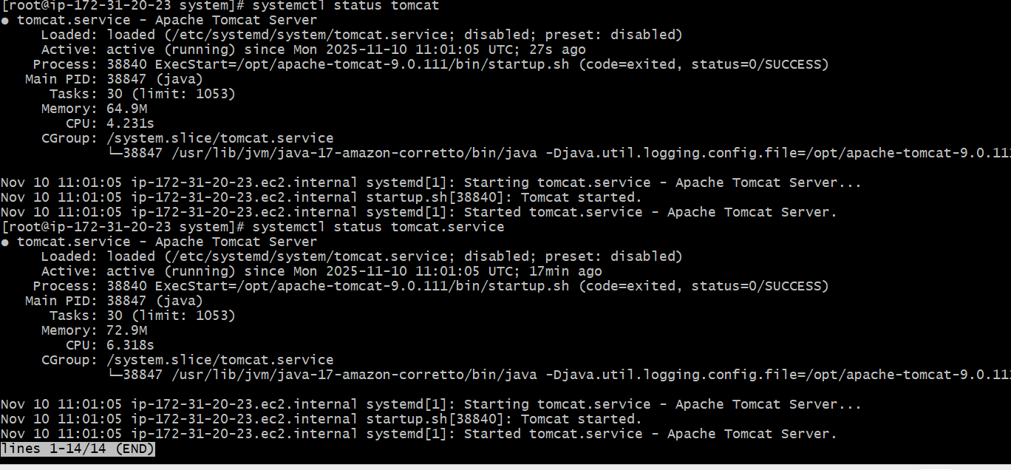

- Configure HA Proxy server
- 